Zen-Core288_XrayMixofSix

Application
Zen-Core288_XrayMixofSix is a crystallographic screen used to detect weakly binding ligands and obtain the x-ray structure in parallel. In many cases, it is much more efficient to screen as mixtures. Express-Zen-Core288™ has a very high shape diversity, making it possible to group into shape diverse mixtures that can be distinguished even at lower resolution.

Physical design
- The library contains a total of 288 compounds plated as mixtures of 6.
- Compounds are plated in the MRC 1 drop 48 well crystallization plate shown below. The mixture of six is dispensed into the drop position of each well. Each mixture contains 0.5μl of a of 200mM compound stock that is dried in each drop so that up to 10μl of stabilization buffer may be added per well for a 10mM soaking solution (for each compound 60mM total).
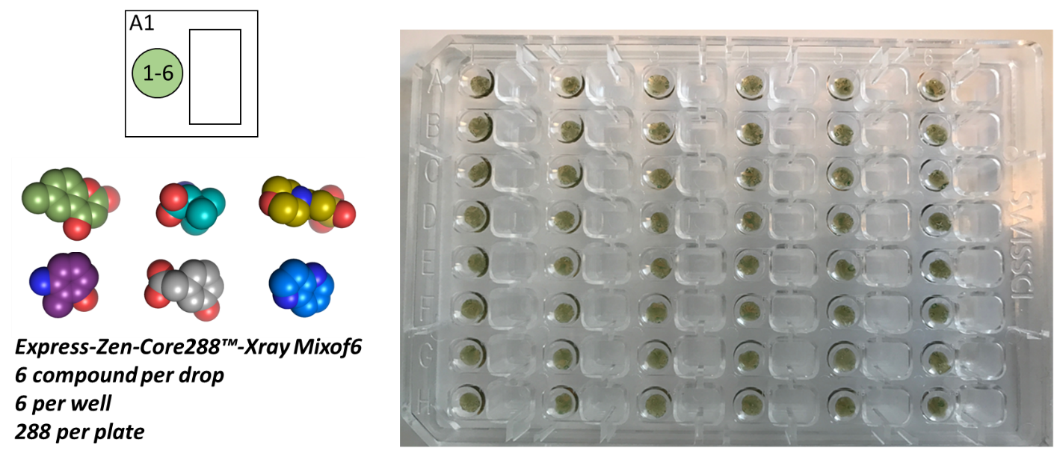

Library preparation
- We recommend that the plate be stored at 4° C until ready for use, then brought to room temperature before use.
- We recommend centrifuging the plate before use to ensure all compound is at the bottom of the well. Plates are centrifuged before shipment.
- Please remove lid carefully to ensure compound remains in the wells.
- The plate is now ready for your own personal screen.

Performing the crystallographic screen
Express-Zen-Core288™ mix of 6 is provided in the MRC Maxi 48-Well Crystallization Plate:
- 0.5μl of 200mM compound dried down for each compound in the mixture of six which is in the drop for each well (288 compounds total).
- Dry compound eliminates need for organic co-solvent in the soak
- Add 50μl of mother liquor to the well and up to 10μl of stabilization buffer to each drop for a 10mM per compound (60mM total compound concentration) soaking stock (lower volumes may be added for higher concentration soaks)
- Compounds may be diluted in a second plate by serial dilution
- Add one or more crystals to each well
- Note that soaking conditions may require optimization for different crystal systems.
- As a starting point, crystals may be soaked overnight at 20mM compound
- Collect data and proceed with standard refinement for unbiased electron density maps
- Inspect map for ligand density not present in the “apo-“ structure
- Use included PDB files to identify which compound in the mixture is bound by matching the shape
- Build complex structures for “hits”
- Once hits are identified, powder re-supply is available from Zenobia for hit verification and additional assays
- Hits may be validated by soaking the single compound version of the hit
- Hits masked by the most potent compound in the mixture may also be soaked to identify additional hits and further validate
- An average of 40 analogues are available for each fragment (SARbyCatalogue). Custom analogue plates are available through Zenobia as a service based upon the collection of hits identified in the screen. Contact us for more details.
- Individual PDB files for all ligands are provided with purchase along with excel and SD files with structures/smiles and plate format

Helpful hints and FAQ
- What should I do to prepare for the crystal screen?
  - Before initiating a crystal screen, it is useful to establish “standard” soaking conditions to understand the tolerability of your crystal to ligands. Because this library is provided as a dry film, one can eliminate the need to test for organic co-solvent tolerance. If your crystallization conditions permit, one may test soaking in cryo-solution to remove the added step of cryoprotection before freezing. In principle, ligands should diffuse into crystals very rapidly (minutes) but it can take longer to reach equilibrium for low solvent content crystals or partially occluded active sites. Zenobia typically soaks overnight, but this is a parameter that may be optimized for each crystal system.
- My crystals cracked when I added them to the soak, what should I do?
  - Crystal cracking can result from a few different scenarios. Typically, one wants to reduce the strain on the crystal by soaking at lower compound concentration for shorter time periods. Crystals may also be uniquely sensitive to certain compounds or compound classes. These compounds may bind at crystal contacts. In this case, gentler soaking conditions may be applied to these specific compounds.
  - If you have not tested soaking for a ligand known to bind to your binding site, the best path forward is to complete this experiment, even if it is a fragment of the ligand or substrate. This will suggest if ligand binding at the active site results in a conformational shift that results in crystal cracking.
  - In some cases, a ligand binding at previously unknown secondary binding sites can result in crystal cracking. If a subset of ligands results in crystal cracking and a co-crystal structure cannot be obtained by soaking, one may set-up more traditional co-crystallization experiments with the ligand to identify a new crystal packing. Ligand may be diluted out of the soaking solution or dry compound may be purchased from Zenobia for additional testing.
  - If you are testing mixtures, and a subset of mixtures results in crystal cracking, one may obtain individual compounds to deconvolute and identify the ligand resulting in the crystal crack.
- Some of the compounds are not soluble in my mother liquor. What should I do?
  - The crystal soak experiment establishes an equilibrium between free ligand and bound ligand. If some of the ligand is not fully dissolved, then the equilibrium includes undissolved ligand, dissolved ligand, and bound ligand. It has been demonstrated that this is not an issue in crystal screening. To ensure that your soak reaches full equilibrium including bound ligand, we suggest soaking these compounds overnight (if the crystal tolerates it).
- How can I use your plates to test different soaking conditions?
  - We suggest preparing the 20mM stock as described and completing serial dilutions of compound into a separate plate to test different soaking concentrations.
- What if I cannot obtain crystals in the absence of ligand? Can I still do a crystal screen?
  - Yes! In many cases, co-crystals may be obtained in the presence of a weakly binding ligand. One may soak this ligand out and soak a new ligand into the crystals. This can work even for very tightly binding ligands, but it may require very long soak times (days) for the ligand to diffuse out of the co-crystal in mother liquor containing no ligand.
  - Alternatively, Zenobia’s plates may also be used for co-crystallization experiments by adding protein and mother liquor directly to the drop and incubating as a typical sitting drop experiment. Compound concentration may be varied by serial dilution as described above.
- I have a hit, now what do I do?
  - This depends on the goal of your project. One may obtain additional dry powder to verify the hit using additional crystallography, an activity assay, or binding experiments. One may also look at the collection and the individual hits to design follow-on screening libraries to improve potency or specificity. Zenobia provides both the dry powder and design of follow-on libraries from this 288-compound collection.
- I didn’t get any hits? How is this possible?
  - If this is a known druggable target, this issue may be technical. If you have not verified that a known ligand binds to your site, complete this experiment.
  - If you do not have a known ligand to test as a control:
    - First, closely examine all of your electron density maps for a feature that is consistent but larger than a water molecule. It is possible that a cryo-molecule or crystallization reagent is binding to the ligand binding site and blocking binding of other ligands.
    - Look closely at the crystal packing, is it possible that the active site is blocked by a neighboring molecule?
    - If this is a “difficult” target, do you have a binding pocket that can accommodate a ligand? Is your target undruggable?
    - Might your protein undergo a conformational change not accommodated in the crystal? Try co-crystallization or test binding by other methods. Zenobia offers screening services beyond crystallography and custom single-use plates for other methods.
  - To verify a lack of hits, one may also set-up co-crystallization experiments
  - Note that Zenobia will supply up to 1 hr of free consultation on projects that provide no hits to aid in troubleshooting. Your success is our success!
For technical support, please contact erika@zenobiatherapeutics.com

